4.2 I can enable others to contribute responsibly to collaborative tasks

During our Teams meeting we talked about Diversity and Inclusion as one of our topics, we all stated our points and had a discussion about how we felt. We stuck to the rules of Netiquette and let other people speak when they had something to say and Shafiq lead the discussion very well.

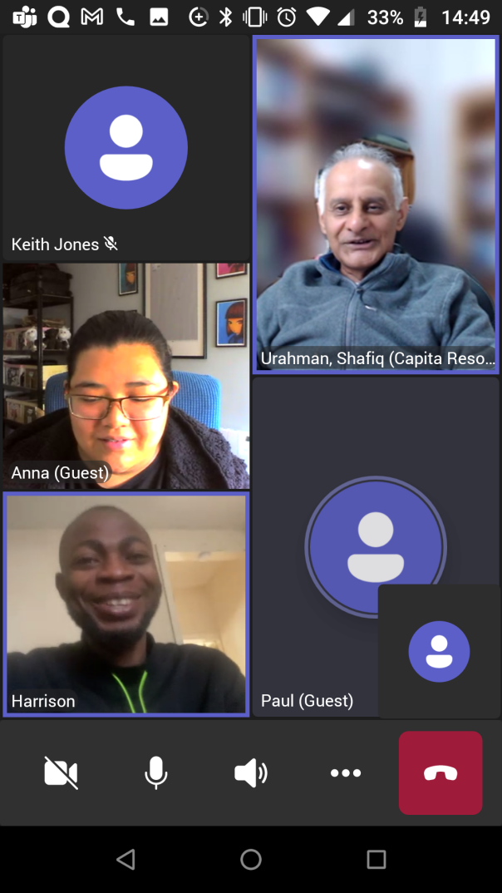

[The above image shows a screenshot of the Teams meeting the class had]